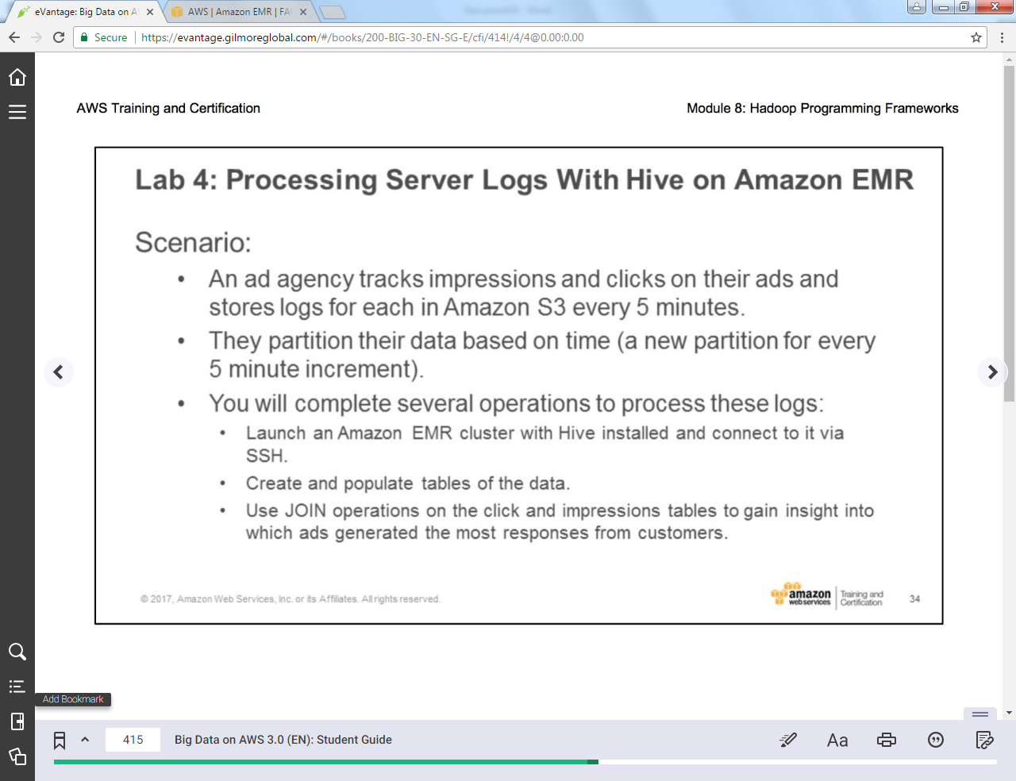

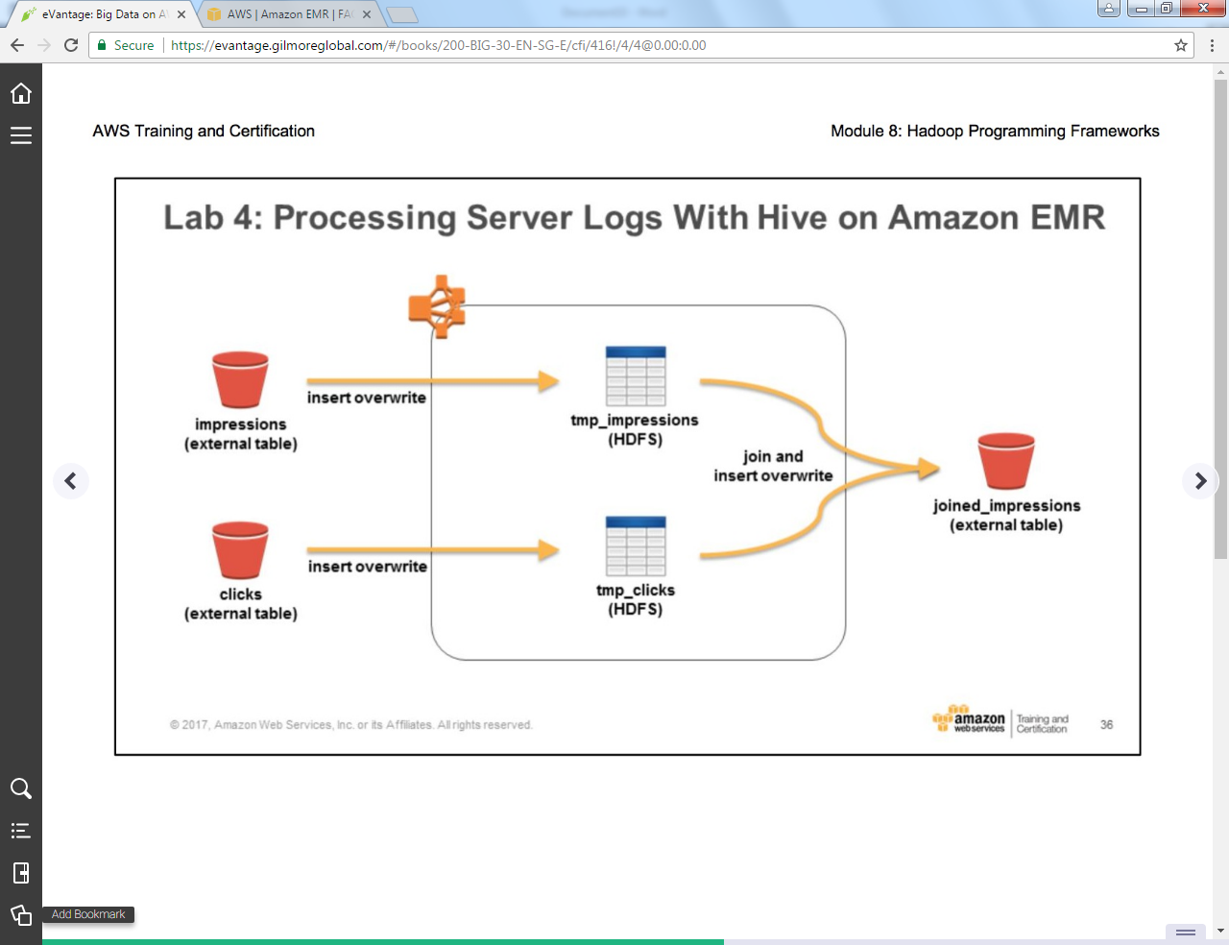

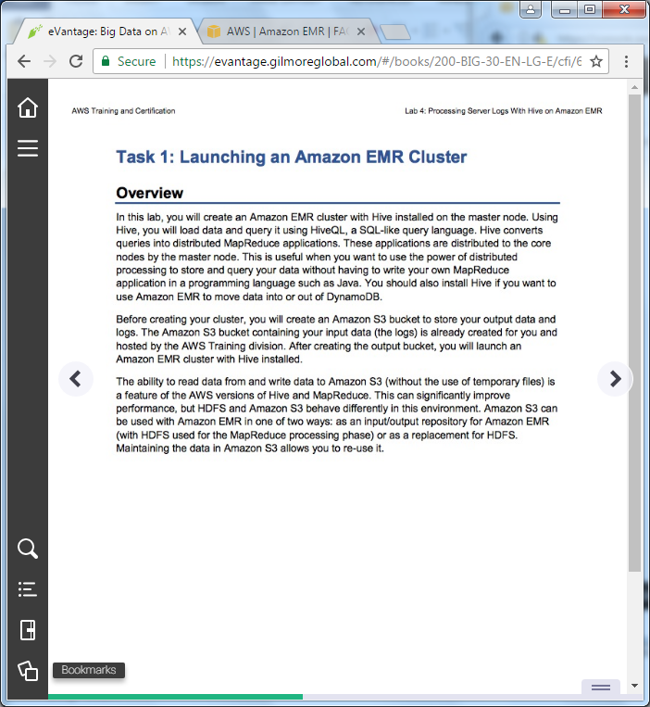

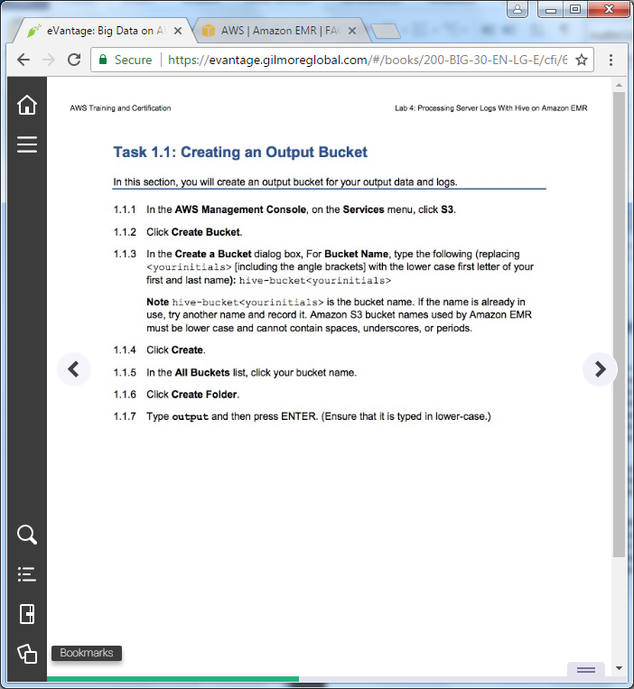

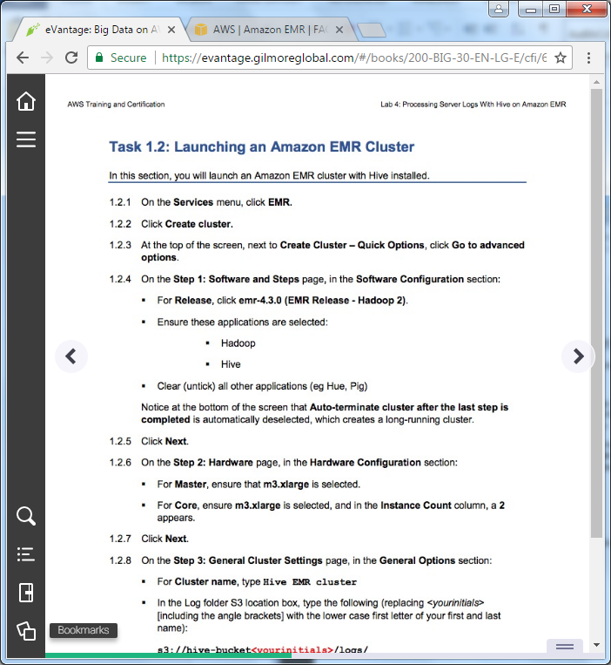

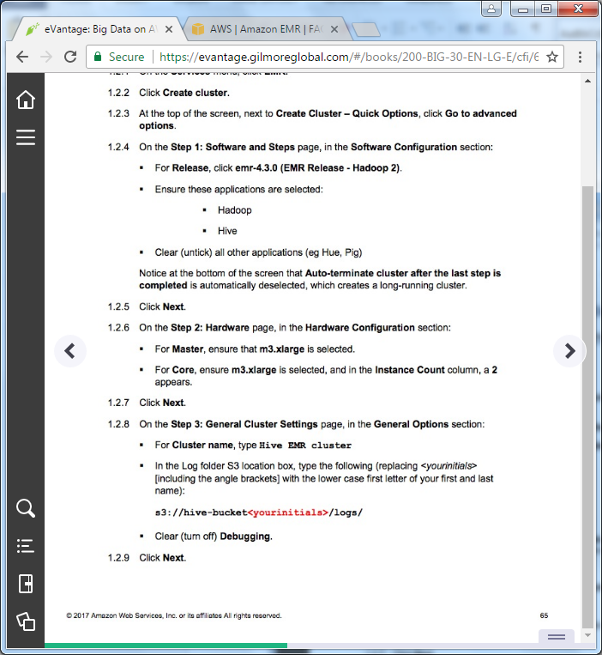

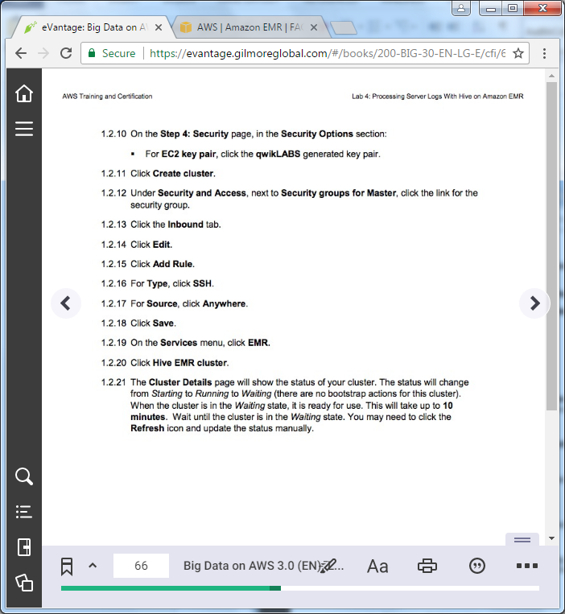

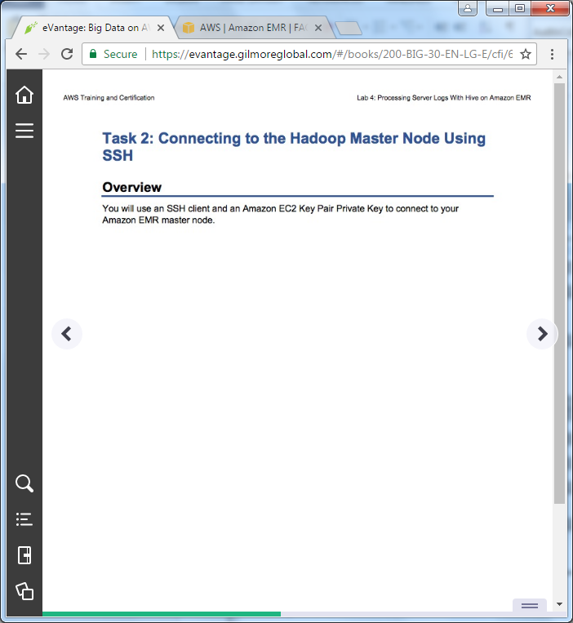

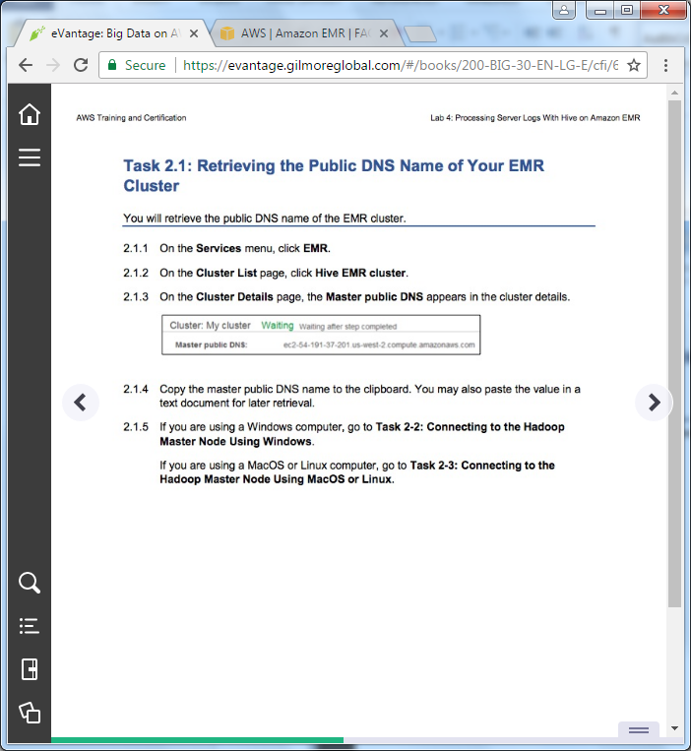

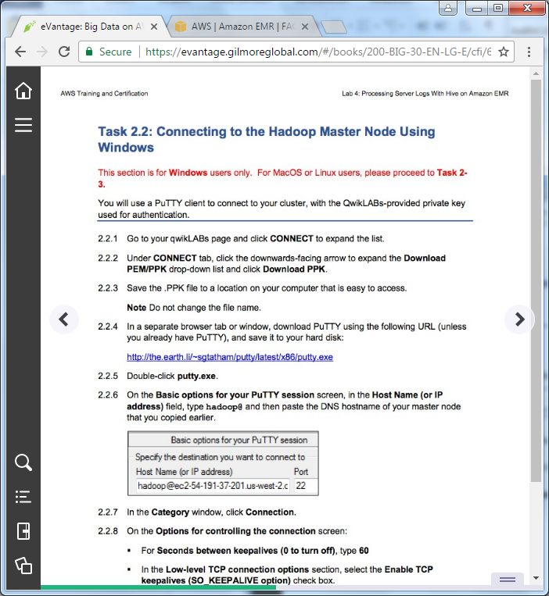

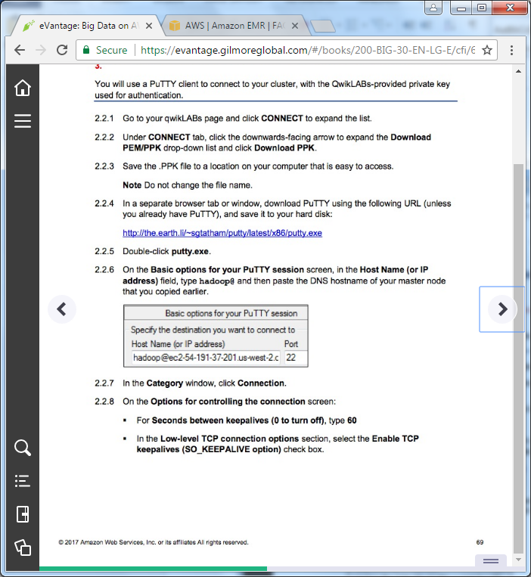

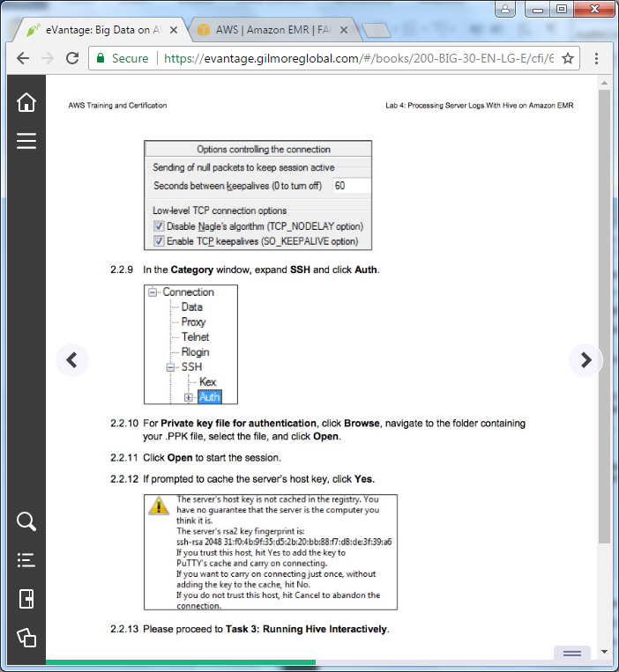

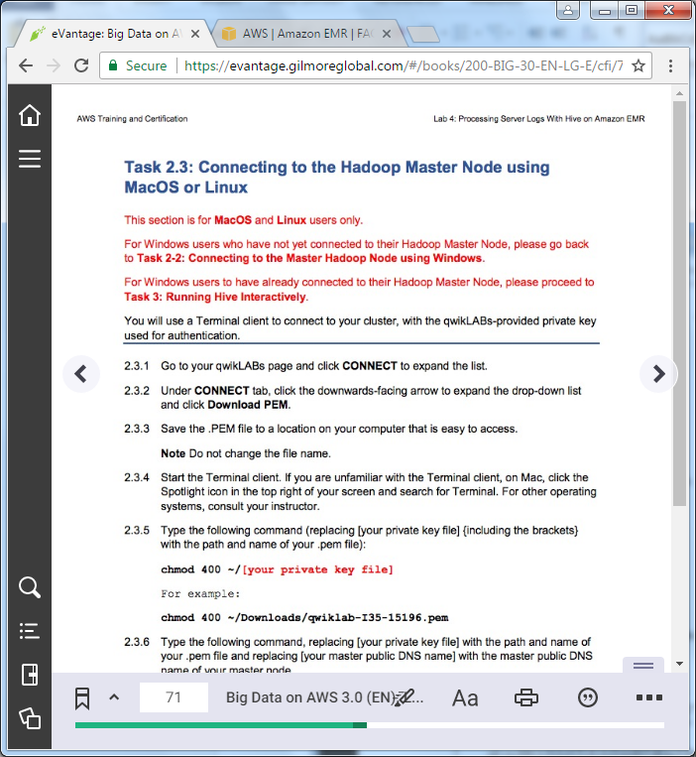

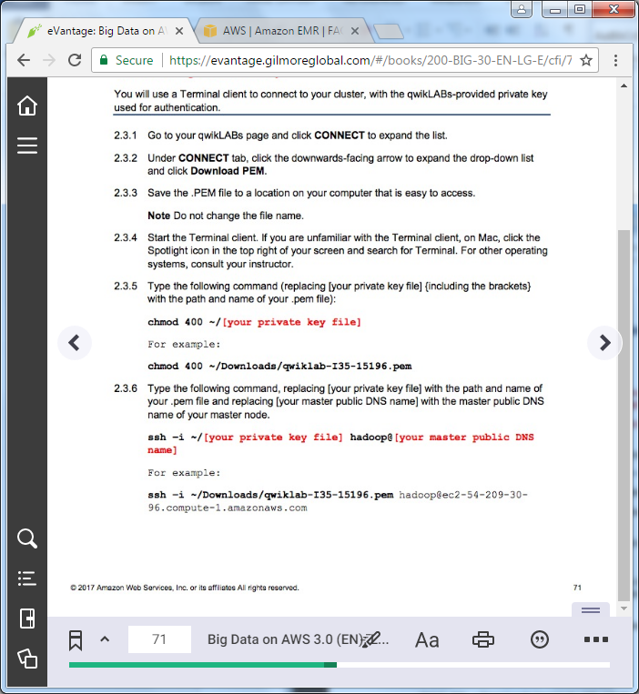

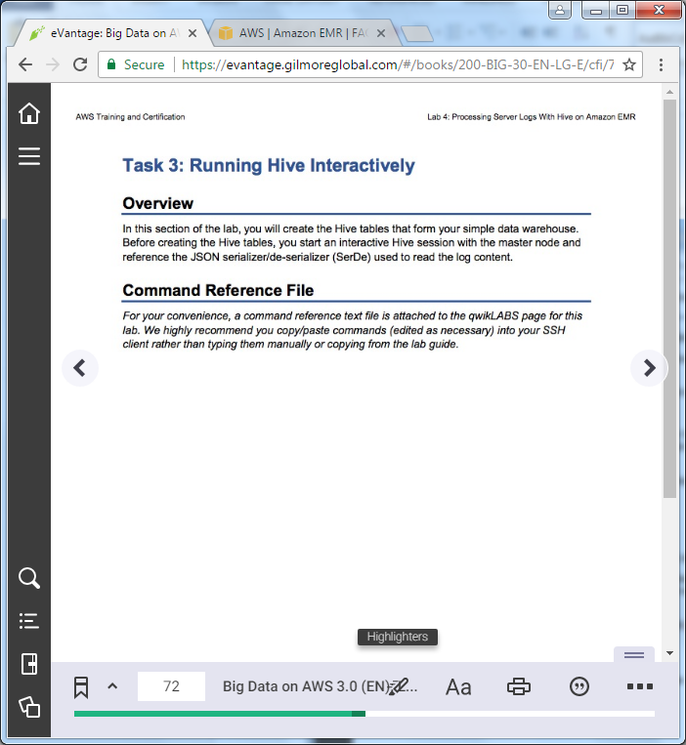

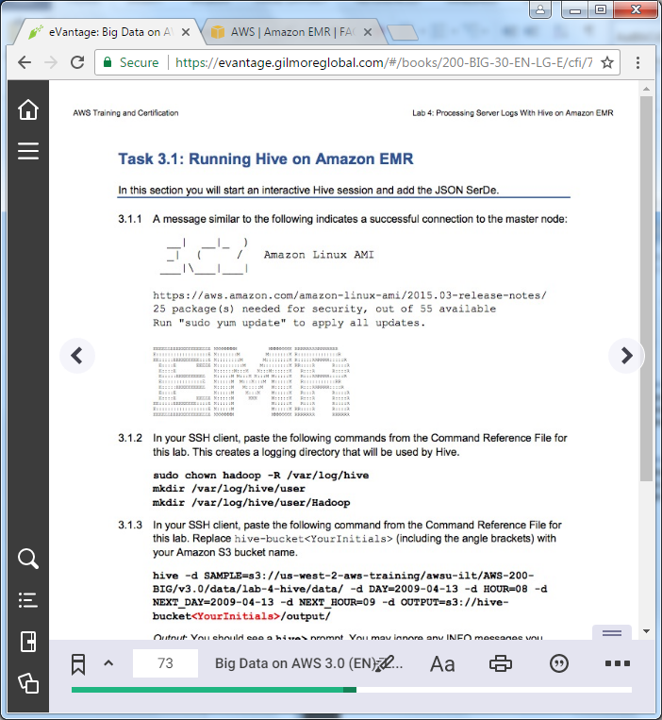

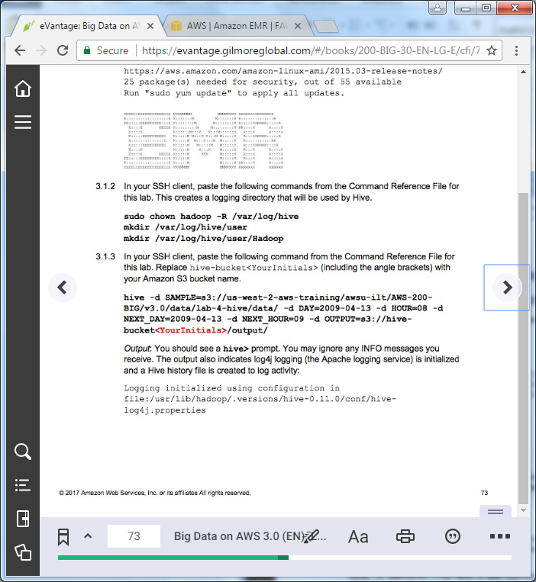

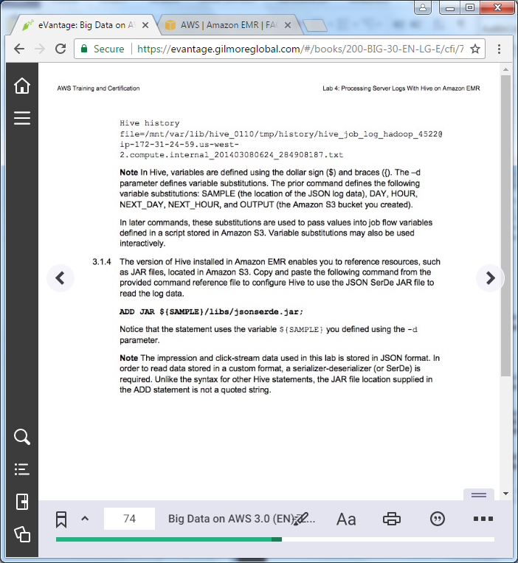

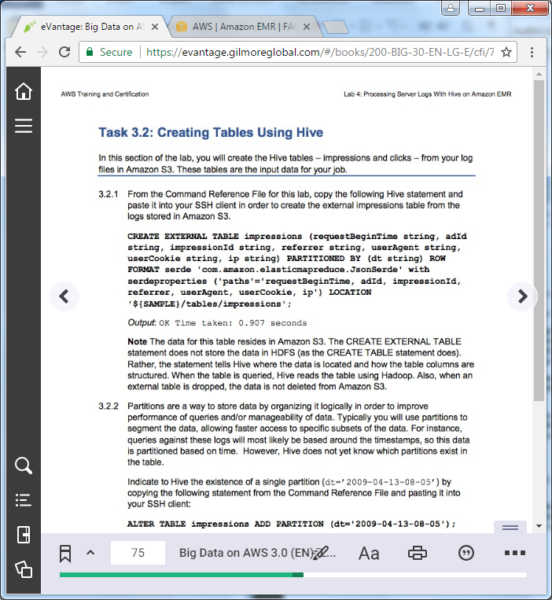

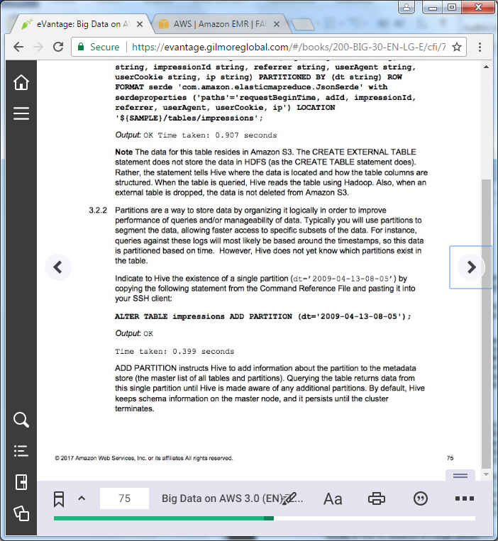

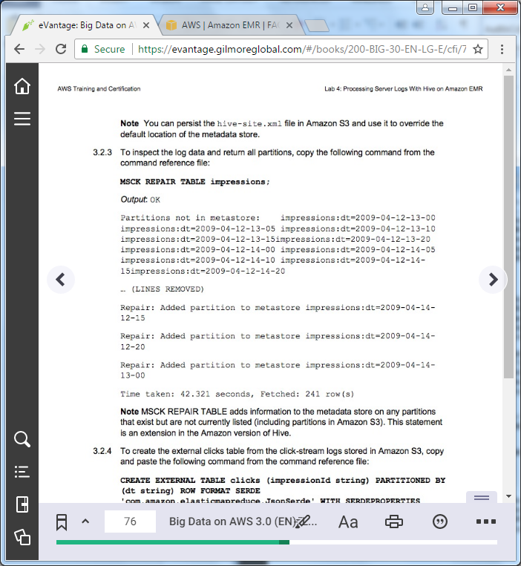

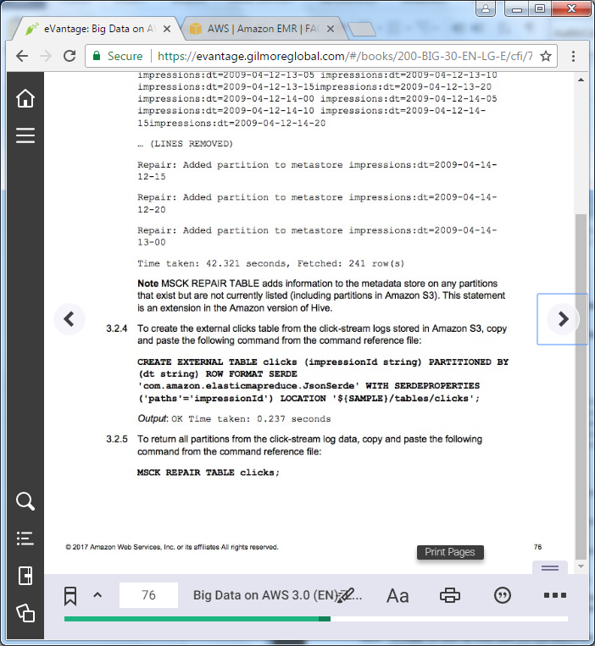

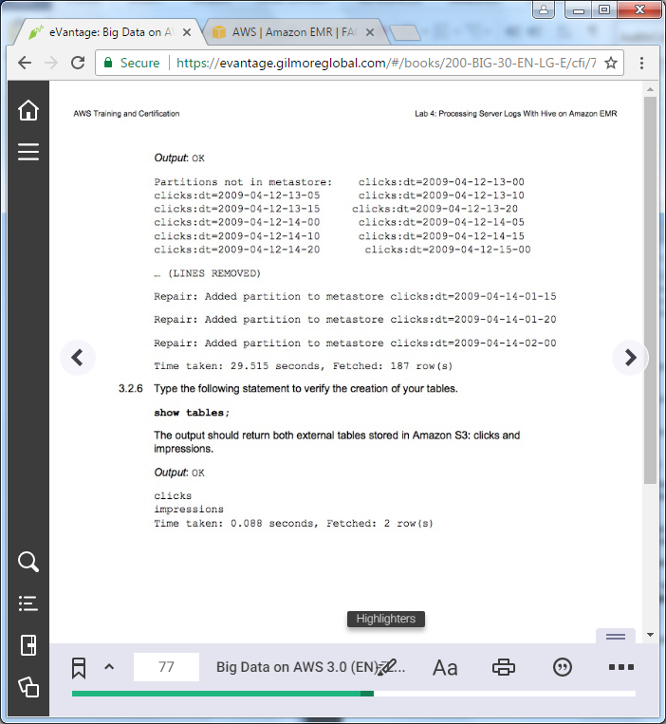

==================================================================================================================

Task 3: Running Hive Interactively

==================================================================================================================

+++ Step 3.1.2

sudo chown hadoop -R /var/log/hive

mkdir /var/log/hive/user

mkdir /var/log/hive/user/hadoop

+++ Step 3.1.3

hive -d SAMPLE=s3://us-west-2-aws-training/awsu-ilt/AWS-200-BIG/v3.0/data/lab-4-hive/data -d DAY=2009-04-13 -d HOUR=08 -d NEXT_DAY=2009-04-13 -d NEXT_HOUR=09 -d OUTPUT=s3://hive-bucket<YourInitials>/output/

+++ Step 3.1.4

ADD JAR ${SAMPLE}/libs/jsonserde.jar;

+++ Step 3.2.1

CREATE EXTERNAL TABLE impressions (requestBeginTime string, adId string, impressionId string, referrer string, userAgent string, userCookie string, ip string) PARTITIONED BY (dt string) ROW FORMAT serde 'com.amazon.elasticmapreduce.JsonSerde' with serdeproperties ('paths'='requestBeginTime, adId, impressionId, referrer, userAgent, userCookie, ip') LOCATION '${SAMPLE}/tables/impressions';

+++ Step 3.2.2

ALTER TABLE impressions ADD PARTITION (dt='2009-04-13-08-05');

+++ Step 3.2.3

MSCK REPAIR TABLE impressions;

+++ Step 3.2.4

CREATE EXTERNAL TABLE clicks (impressionId string) PARTITIONED BY (dt string) ROW FORMAT SERDE 'com.amazon.elasticmapreduce.JsonSerde' WITH SERDEPROPERTIES ('paths'='impressionId') LOCATION '${SAMPLE}/tables/clicks';

+++ Step 3.2.5

MSCK REPAIR TABLE clicks;

+++ Step 3.2.6

show tables;

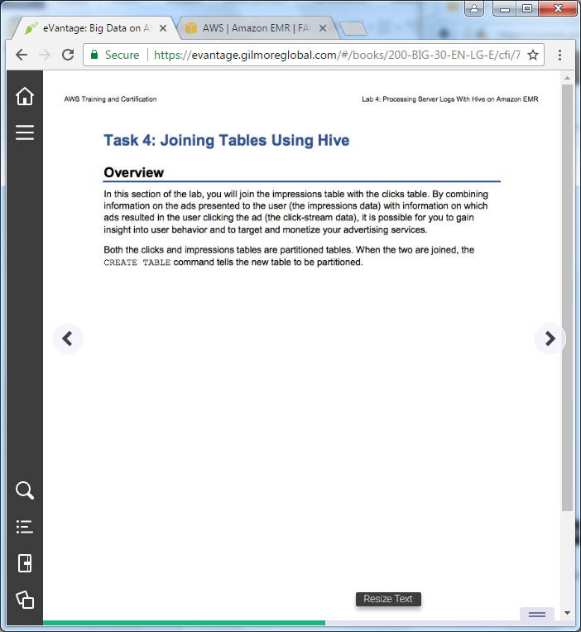

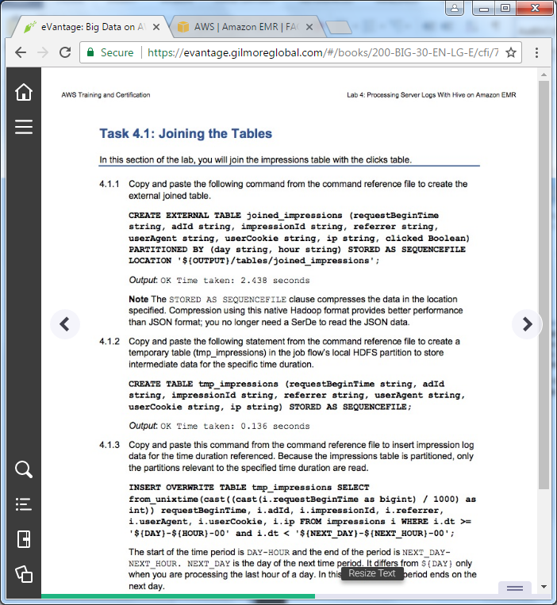

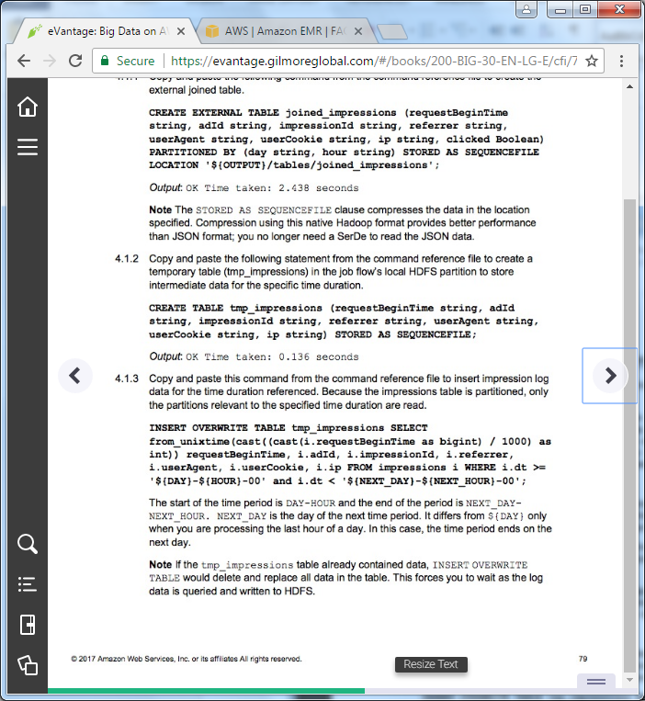

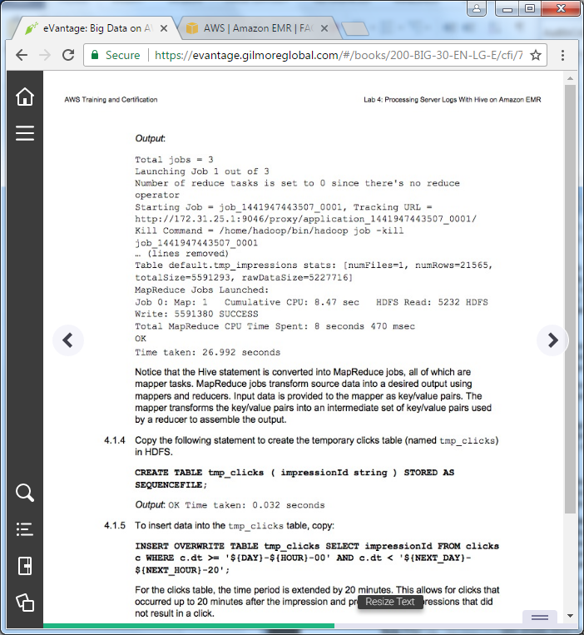

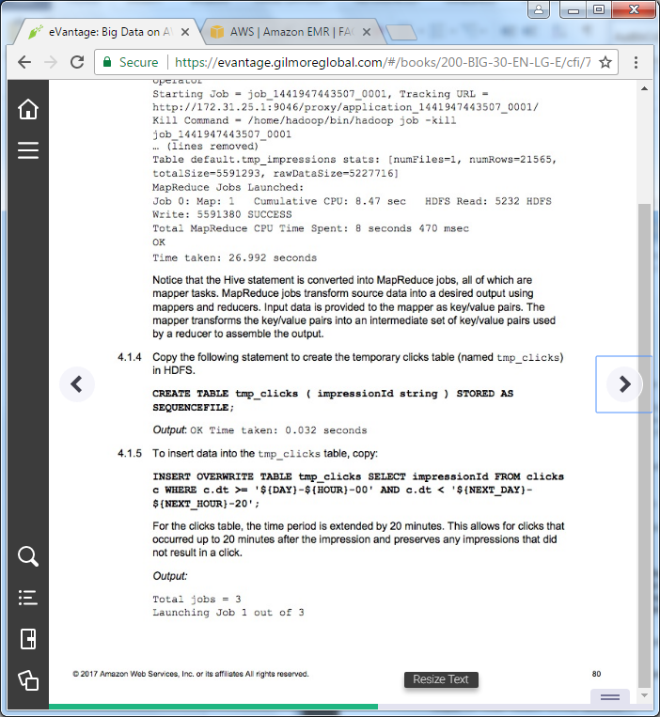

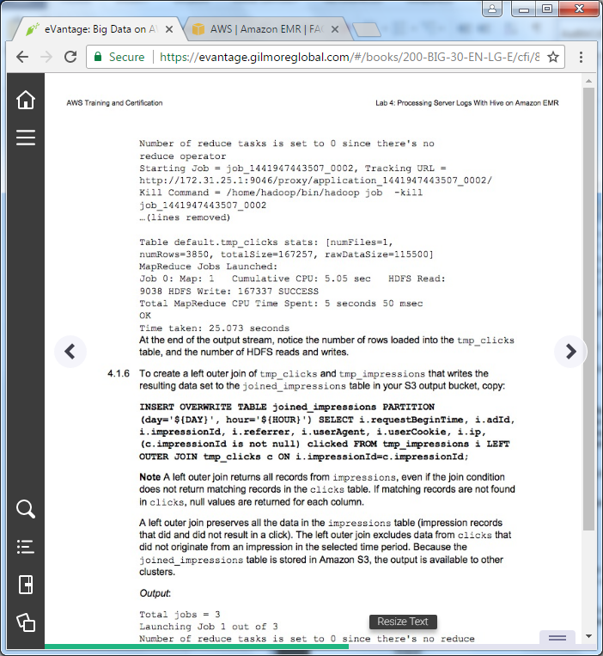

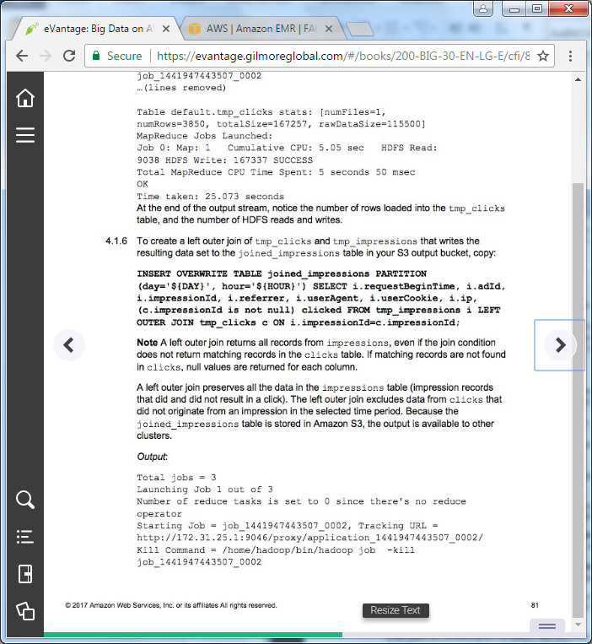

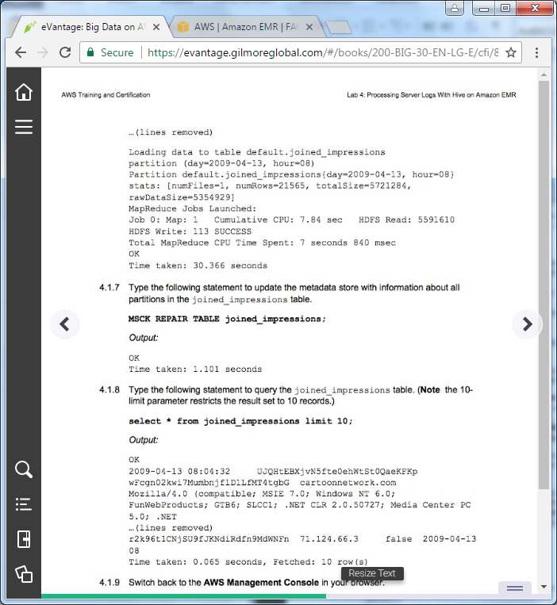

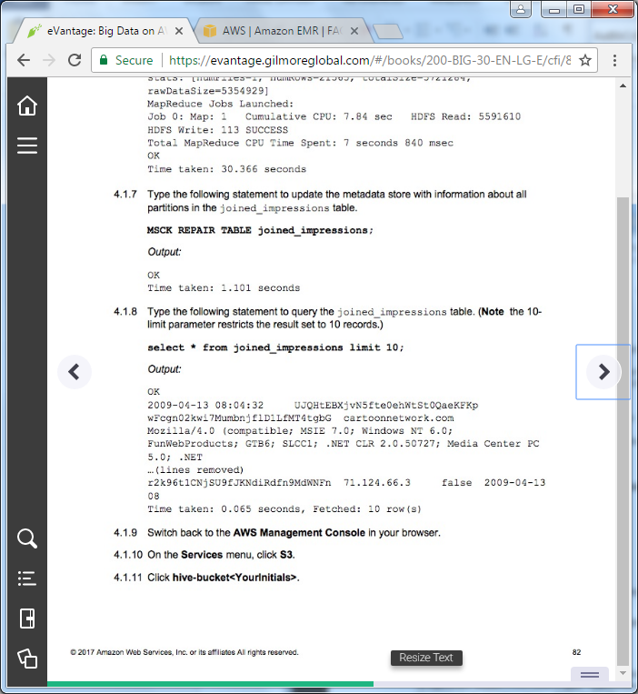

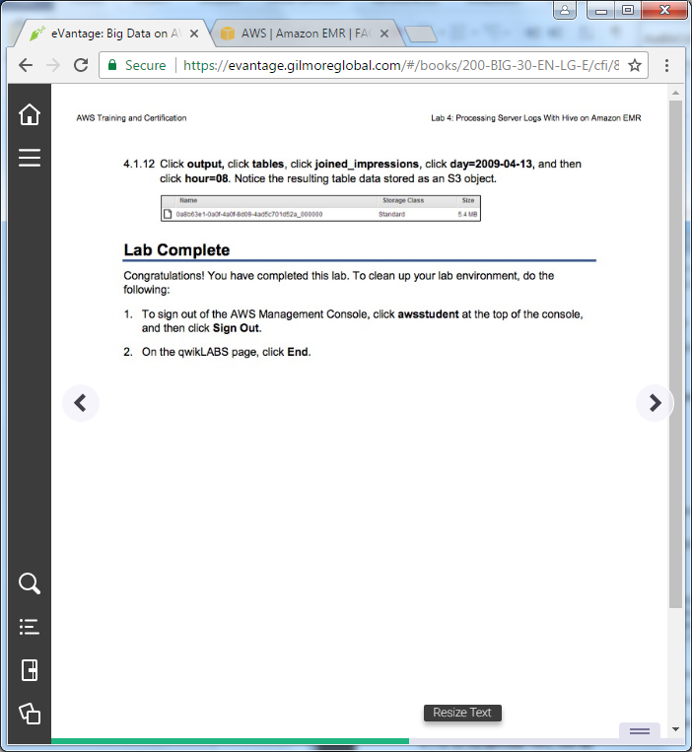

==================================================================================================================

Task 4: Joining Tables Using Hive

==================================================================================================================

+++ Step 4.1.1

CREATE EXTERNAL TABLE joined_impressions (requestBeginTime string, adId string, impressionId string, referrer string, userAgent string, userCookie string, ip string, clicked Boolean) PARTITIONED BY (day string, hour string) STORED AS SEQUENCEFILE LOCATION '${OUTPUT}/tables/joined_impressions';

+++ Step 4.1.2

CREATE TABLE tmp_impressions (requestBeginTime string, adId string, impressionId string, referrer string, userAgent string, userCookie string, ip string) STORED AS SEQUENCEFILE;

+++ Step 4.1.3

INSERT OVERWRITE TABLE tmp_impressions SELECT from_unixtime(cast((cast(i.requestBeginTime as bigint) / 1000) as int)) requestBeginTime, i.adId, i.impressionId, i.referrer, i.userAgent, i.userCookie, i.ip FROM impressions i WHERE i.dt >= '${DAY}-${HOUR}-00' and i.dt < '${NEXT_DAY}-${NEXT_HOUR}-00';

+++ Step 4.1.4

CREATE TABLE tmp_clicks ( impressionId string ) STORED AS SEQUENCEFILE;

+++ Step 4.1.5

INSERT OVERWRITE TABLE tmp_clicks SELECT impressionId FROM clicks c WHERE c.dt >= '${DAY}-${HOUR}-00' AND c.dt < '${NEXT_DAY}-${NEXT_HOUR}-20';

+++ Step 4.1.6

INSERT OVERWRITE TABLE joined_impressions PARTITION (day='${DAY}', hour='${HOUR}') SELECT i.requestBeginTime, i.adId, i.impressionId, i.referrer, i.userAgent, i.userCookie, i.ip, (c.impressionId is not null) clicked FROM tmp_impressions i LEFT OUTER JOIN tmp_clicks c ON i.impressionId=c.impressionId;

+++ Step 4.1.7

MSCK REPAIR TABLE joined_impressions;

+++ Step 4.1.8

select * from joined_impressions limit 10;